

**KOLEJ PROFESIONAL MARA BERANANG**

**IOT PROJECT PROPOSOL**

**SESSION 1 2 2022/2023**

**PREPARED FOR:**

TUAN ZAKARIA BIN ROSMAN

**PREPARED BY:**

AISYAH AINA SUFIA BINTI HILMAN

**MENTOR’S NAME:**

PUAN NOOR FAZLIANI BINTI SHAMSHUDIN

**Scenario**

IoT is a rapidly growing technology in Malaysia, in line with the development of IR 4.0. MARA Professional College, Beranang (MPCB) is not left behind in using IoT technology to improve the college environment for the use of staff and students. In this regard, lecturers and students for the "Internet of Things" (IoT) course are responsible for finding spaces that can apply IoT technology in colleges to keep up with the latest technology.

As a student of IoT course in KPMB, you are assigned to perform a group of 4 students. By working in groups, you are required to select one IoT domain for the development IoT project. The initial step is to prepare a project proposal in terms of cost and IoT design methodology. You may choose from several domains such as Home automation, Cities, Environment, Agriculture, Industry, Logistic or Health. Below are the tasks that you need to accomplished in order to propose the new IoT project for MARA Professional College, Beranang (MPCB). *Refer Appendix 1: The template of Project Proposal.*

**Tasks:**

1. Prepare a **Project Proposal** for the proposed IoT project.

1a. Introduction (Project overview)

1b. Problem Statement 1c. 1c.Objectives.

1d. Gantt Chart/Timeliness

1. Prepare a **Project Costing** for the proposed IoT project.

1a. Iot devices

1b. Iot network devices

1c. Service support and application support: cloud or on-premises

1d. IoT Application

**ii**

1. In your proposal, define specification for each step in the **IoT System Design Methodology**.

Step 1: Purpose and Requirements Specification

Step 2: Process Specification

Step 3: Domain Model Specification

Step 4: Information Model Specification

Step 5: Service Specifications

Step 6: IoT Level Specification

Step 7: Functional View Specification

Step 8: Operational View Specification

Step 9: Device and Component Integration

Step 10: Application Development

1. Discuss **IoT Systems-Logical Design using Python** for the proposed IoT project.

**iii**

1. TABLE OF CONTENT

|  |  |  |
| --- | --- | --- |
| **NO.** | **TOPIC** | **Pages** |
| **1.0** | **IOT PROJECT PROPOSAL** | **1** |
|  | 1.1) Project Introduction (Overview) | 1 |
|  | 1.2) Problem Statement | 2 |
|  | 1.3) Objectives | 3 |
|  | 1.4) Gantt Chart | 6 |
|  |  |  |
|  |  |  |
| **2.0** | **PROJECT COSTING** | **7** |
|  | 2.1) IOT Devices  2.1.1) Hardware  2.1.2) Software  2.1.3) Ectra Tools | 7 |
|  | 2.2) IOT NETWORK DEVICES | 29 |
|  | * 1. SERVICE SUPPORT & APPLICATION SUPPORT: CLOUD | 30 |
|  | * 1. IOT APPLICATION | 32 |
|  |  |  |
| **3.0** | IOT PROJECT’S PROPOSAL SYSTEM DESIGN METHODOLOGY | **33** |
|  |  |  |
| **4.0** | Systems-Logical Design using Python for IoT proposed project | **48** |

1. **PROJECT PROPOSAL**
   1. Project Introduction (Overview)

Floods always strike unexpectedly and without warning. As technology advances, it assists individuals in making their daily lives simpler. This IoT-based Flood Monitoring And Alerting System technology helps in the monitoring and alerting of flood victims. By using one of the newest microcontroller technologies which is Arduino Uno R3, this system can be developed.

This system, which combined hardware and software, required some programming for interface. The ultrasonic sensor will be effective for collecting flood data by measuring the water level distance in a flood, which will be converted to a percentage using a metre in order to create a decision-making system. Users may monitor floods from afar by seeing the output of the water level on an LCD (Liquid Crystal Display) and receiving a warning message by SMS and email via software services Mailgun and Twillio.

The working principle for this mechanism begin with when water level is at Normal level, that resembles 'Green Alert'. This indicates that water is at normal position. So, no sign about flood condition and green led will glow as well as a green alert in LCD display with water level.

When water level rises the Intermediate level, It resembles 'Orange Alert'. This indicates that the water level has reached the 55% mark and orange led will light up and buzzer will make sound of ‘buzz’. It will also show orange alert in LCD display. With increase in water level, the system sends SMS and E-mail notification to the authority or registered user via Twillo and Mailgun Services, with the appropriate message and current temperature of the location, as there is a risk of flooding.

1

When water level crosses the Max Level. That resembles 'Red Alert'. This means that water level has crossed the 80% and flood situation has occured at that place. When the water level rises, the system sends SMS and E-mail notifications through Twillo and Mailgun Services to the authority or registered user, with the appropriate

message and current temperature of the location. A red led will also illuminate, and the buzzer will sound twice. The LCD panel will also show a red alrt in LCD display.

* 1. Problem Statement

Flooding is a natural calamity that may strike at any time and without warning. Floods are frequently caused by a combination of excessive rainfall and other local conditions, such as landslides. Due to its proximity to the equator, Malaysia is prone to year-round climatic variations .Take a look on of latest news that occured in Shah Alam , Klang and certain location in Selangor on December 20/2021 , which there was unexpected heavy flood at the places despite no forecast of extraordinary weather patterns. Same goes to MARA Professional College, Beranang (MPCB) which need to be prepared if there is unexpected flood striking at the college.

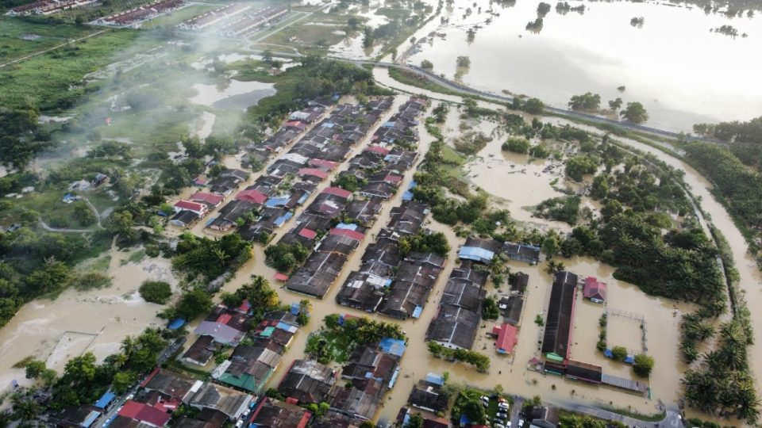

Figure1 : Aerial view of the flood situation around Universiti Selangor (Unisel) and part of Bestari Jaya town, in Kuala Selangor, on December 20, 2021. — Picture via FACEBOOK/MPKS

2

Extreme rainfall can lead to flash floods and other natural catastrophes as a result of climate change. Floods are well-known for causing tremendous damage, including the destruction of homes and property, the loss of crops and plants , vehicle damaged and will lead to worse serious case which is the extinction of livestock. When they are submerged, both humans and animals must wait for help to arrive.

The existing detector was solely used to monitor on water levels in some places. In addition to monitor and collecting data, the presence of a flood detector and warning system will allow individuals to receive an early warning of a potential flood, allowing them time to save their belongings and family and friends before the flood becomes more deadly. In this way, it will lower the chance of aforementioned issues.

* 1. Objectives

There are some objectives that have to be achieved in this :

1. To design a system which can reduce the impact and cost of the flood damage by providing warning, monitoring and detect of local flooding for people.
2. To build a prototype system of flood detector using hardware and software provided in order to test and validate the working of the built system.
3. To understand the Arduino Uno applications and the basic concept of communication system.

3

* 1. Project Proposal’s Gantt Chart

(The Gantt Chart link is Same as a student name Nur Aleeya Fasha (groupmate) since I had technical error to provide the link)

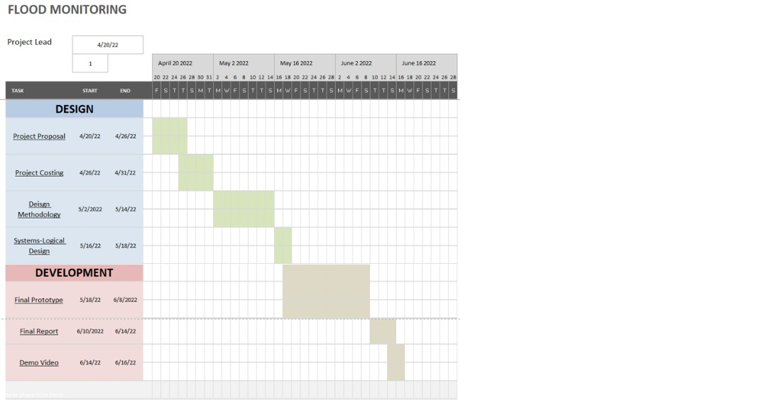

6

1. **PROJECT’S COSTING**
   1. IoT Devices

IoT devices divided into Hardware and software:

2.1.1) Hardware

1. Arduino Uno R3 : Rev3 V3 Atmel ATMEGA328P Compatible Board Plug and Play

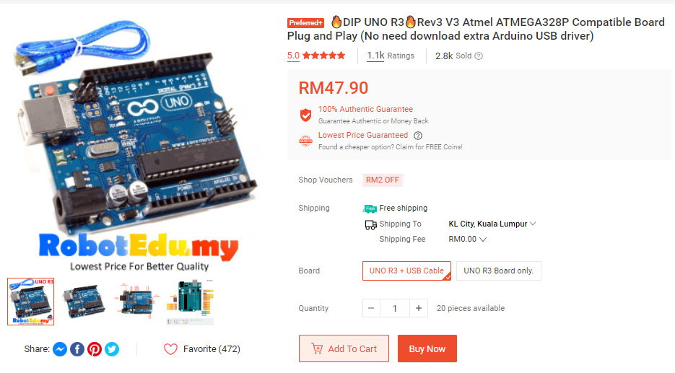

( Link Purchase : <https://shopee.com.my/%F0%9F%94%A5DIP-UNO-R3%F0%9F%94%A5Rev3-V3-Atmel-ATMEGA328P-Compatible-Board-Plug-and-Play-(No-need-download-extra-Arduino-USB-driver)-i.33091591.466533399?sp_atk=1b686921-e3c7-4173-8420-cedf4c860f63&xptdk=1b686921-e3c7-4173-8420-cedf4c860f63> )

7

1. MB102 Solderless Mini Medium Large Breadboard 170 400 830 Holes Dupont Jumper Wire EE Components Experiment Donut Board

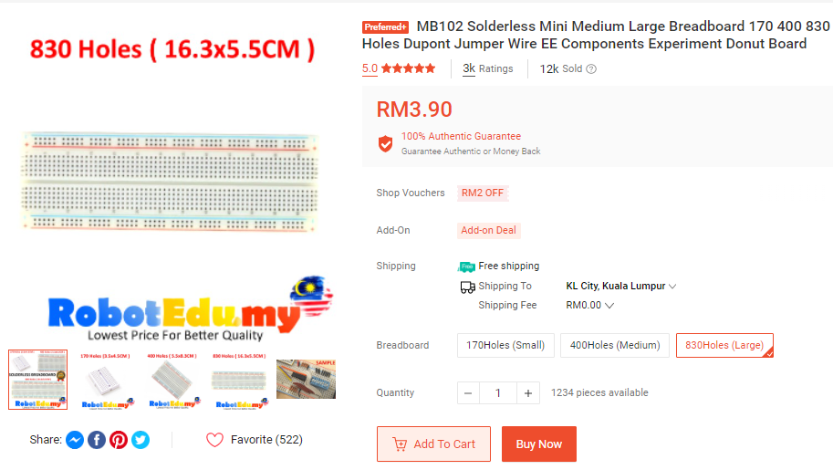

(Link Purchase : <https://shopee.com.my/MB102-Solderless-Mini-Medium-Large-Breadboard-170-400-830-Holes-Dupont-Jumper-Wire-EE-Components-Experiment-Donut-Board-i.33091591.547814043?sp_atk=5bc4181a-995a-49d1-805c-2262312a5310&xptdk=5bc4181a-995a-49d1-805c-2262312a5310> )

8

1. LED 5mm Diffused / Clear [Red Green Yellow] Arduino UNO Breadboard Raspberry PCB Circuit

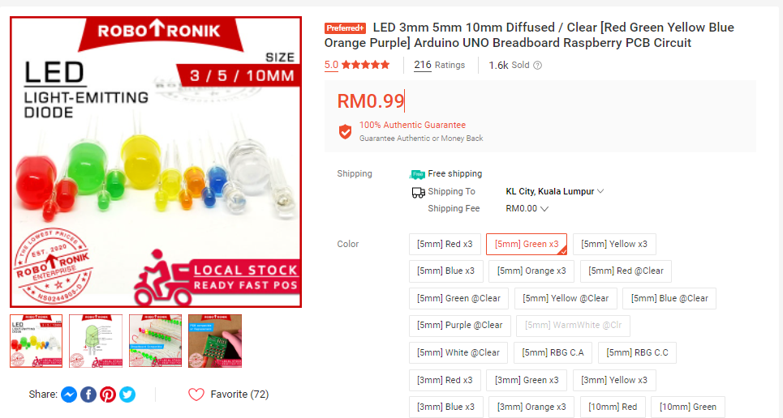

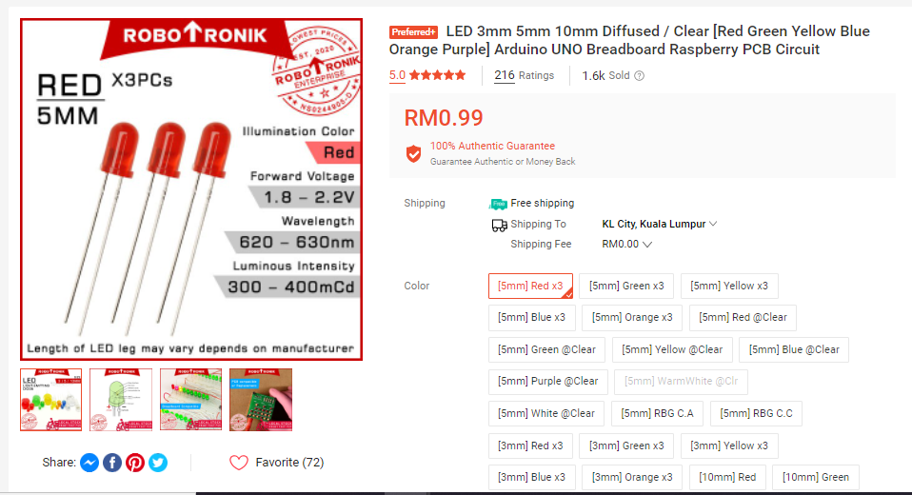

9

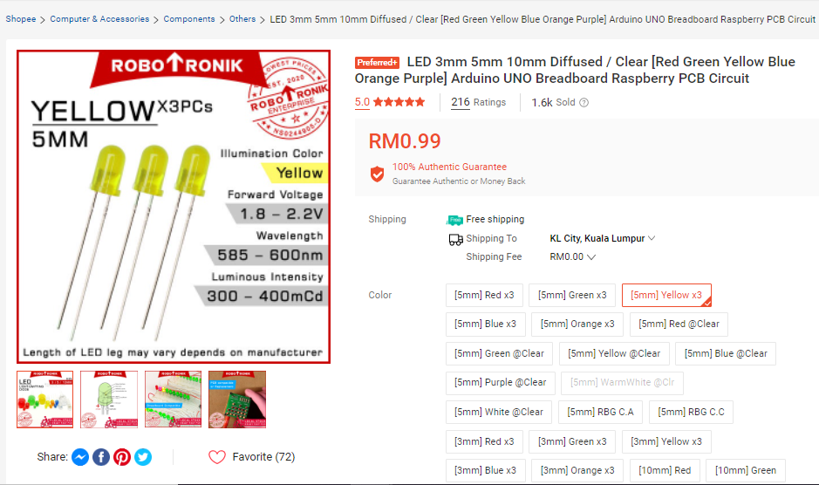

( Link Purchase : <https://shopee.com.my/LED-3mm-5mm-10mm-Diffused-Clear-Red-Green-Yellow-Blue-Orange-Purple-Arduino-UNO-Breadboard-Raspberry-PCB-Circuit-i.126211897.5091094715?sp_atk=d78fe0ef-aa2e-49da-b11b-9a1b0fa000f6&xptdk=d78fe0ef-aa2e-49da-b11b-9a1b0fa000f6> )

10

1. 1pcs 3V-12V Passive Buzzer

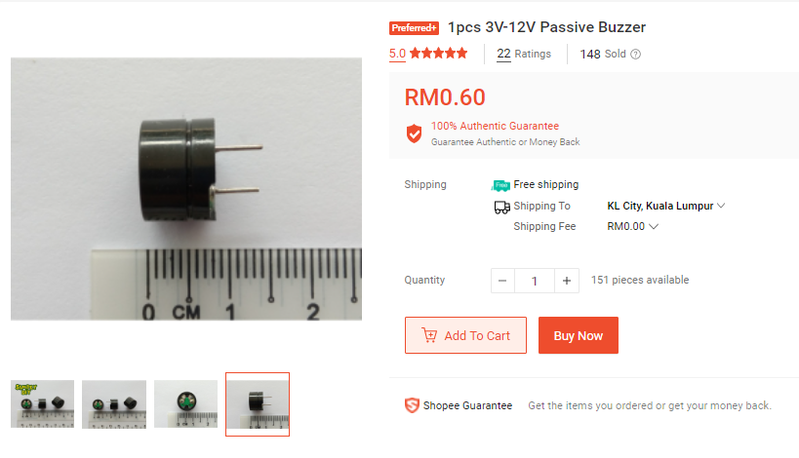

(LinkPurchase:<https://shopee.com.my/1pcs-3V-12V-Passive-Buzzer-i.97601804.3874453803?sp_atk=2aac485d-df86-439c-b1a0-84ba49d481b9&xptdk=2aac485d-df86-439c-b1a0-84ba49d481b9> )

11

1. Arduino LCD Display 16x2 Yellow

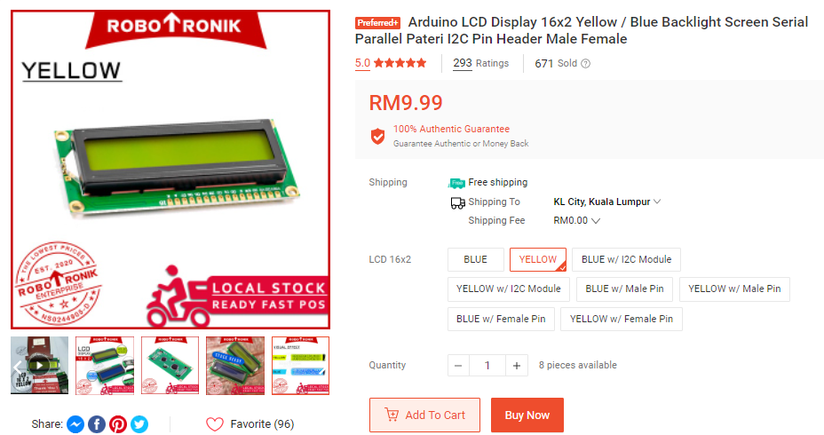

( Link Purchase : <https://shopee.com.my/Arduino-LCD-Display-16x2-Yellow-Blue-Backlight-Screen-Serial-Parallel-Pateri-I2C-Pin-Header-Male-Female-i.126211897.7963462850?sp_atk=6ac05a20-c435-4189-88a7-f3a1738c3e56&xptdk=6ac05a20-c435-4189-88a7-f3a1738c3e56> )

12

1. DHT11 / DHT22 DHT 11 22 High Accuracy Temperature and Humidity Moisture Sensor 3.3V 5V Module

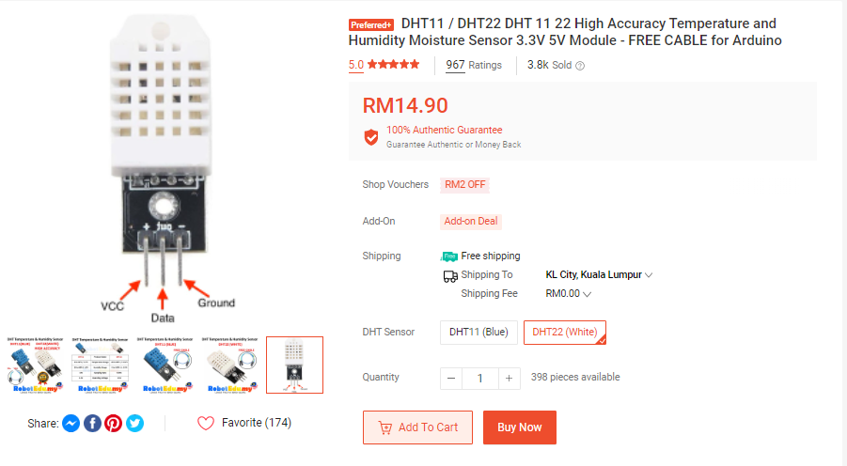

( Link Purchase : <https://shopee.com.my/product/33091591/572008040?smtt=0.457092078-1653041045.3> )

13

1. Ultrasonic Sensor HC-SR04 HC SR 04 Ultrasound Range Finder Distance Measure Measurement Module for Arduino Robotics

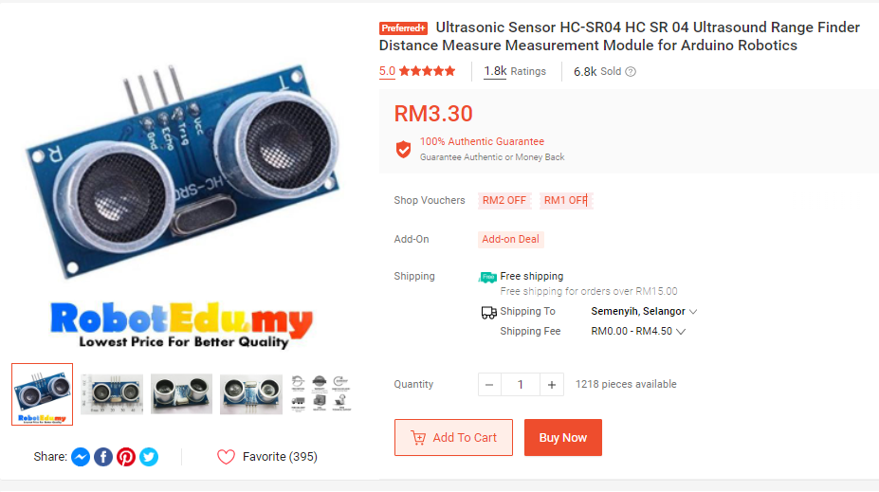

( Link Purchase : <https://shopee.com.my/Ultrasonic-Sensor-HC-SR04-HC-SR-04-Ultrasound-Range-Finder-Distance-Measure-Measurement-Module-for-Arduino-Robotics-i.33091591.521968026> )

14

1. Male to Male (MM) 40pcs Dupont Jumper Wire DIY Experiment Breadboard Rainbow 40p Wires Cable 10cm 20cm 30cm for Arduino

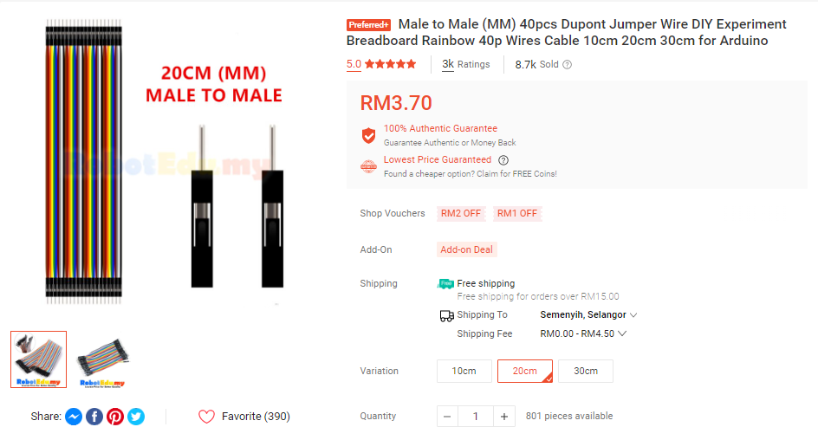

( Link Purchase : <https://shopee.com.my/Male-to-Male-(MM)-40pcs-Dupont-Jumper-Wire-DIY-Experiment-Breadboard-Rainbow-40p-Wires-Cable-10cm-20cm-30cm-for-Arduino-i.33091591.524229147> )

15

1. Female to Female (FF) 40pcs Dupont Jumper Wire DIY Experiment Breadboard Rainbow Cable 40P 10cm 20cm 30cm for Arduino

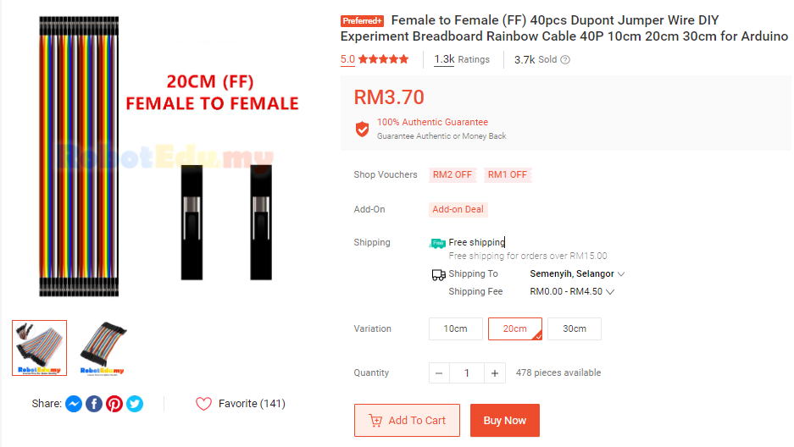

( Link Purchase : <https://shopee.com.my/Female-to-Female-(FF)-40pcs-Dupont-Jumper-Wire-DIY-Experiment-Breadboard-Rainbow-Cable-40P-10cm-20cm-30cm-for-Arduino-i.33091591.460617425> )

16

1. Female to Male (FM) 40pcs Dupont Jumper Wire DIY Experiment Breadboard Rainbow Cable 40p 10cm 20cm 30cm for Arduino

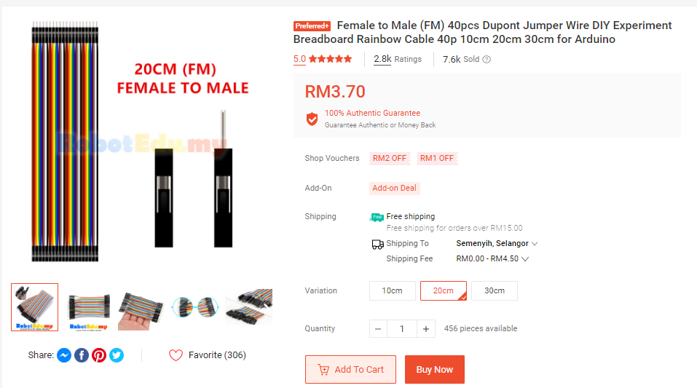

( Link Purchase : <https://shopee.com.my/Female-to-Male-(FM)-40pcs-Dupont-Jumper-Wire-DIY-Experiment-Breadboard-Rainbow-Cable-40p-10cm-20cm-30cm-for-Arduino-i.33091591.460621073> )

17

1. [Genuine] GP Battery 9V Bateri Supercell Heavy Duty Smart Tag Toys Walkie Talkie Radio Microphone Thermometer Car Mainan

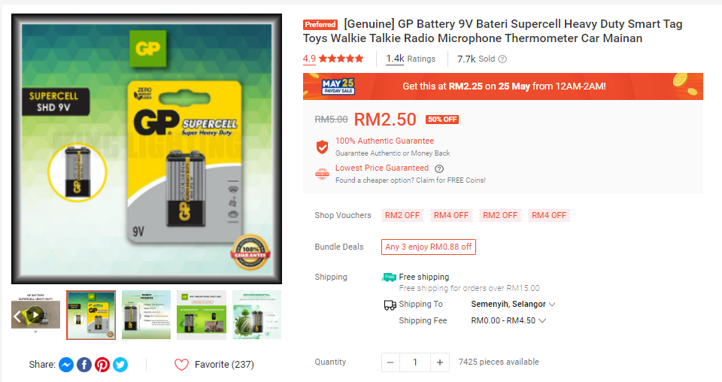

( Link Purchase : <https://shopee.com.my/-Genuine-GP-Battery-9V-Bateri-AC-Heavy-Duty-Smart-Tag-Toys-Walkie-Talkie-Radio-Microphone-Thermometer-Car-Mainan-i.188912252.9927479754?sp_atk=a7782c65-1aeb-470a-a665-f48108b5ee9d&xptdk=a7782c65-1aeb-470a-a665-f48108b5ee9d> )

18

1. 50cm USB 2.0 A Female to USB B Male Cable for Printer Extender Connection Cable

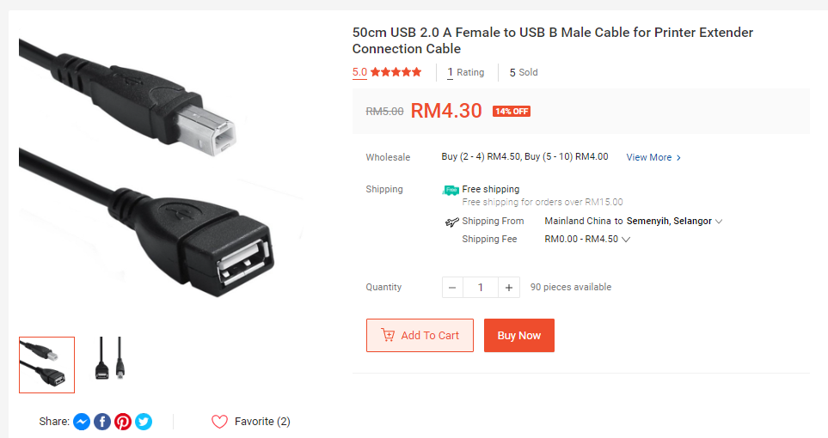

( Link Purchase : <https://shopee.com.my/50cm-USB-2.0-A-Female-to-USB-B-Male-Cable-for-Printer-Extender-Connection-Cable-i.195229225.7963731576?sp_atk=544a9619-0b68-4567-b8f4-9285cabc1d09&xptdk=544a9619-0b68-4567-b8f4-9285cabc1d09> )

19

* **Total Cost** IoT Hardware Devices for Project’s Proposal

|  |  |  |  |  |
| --- | --- | --- | --- | --- |
| No. | Product Name | Price per Unit  (RM) | Quantity  (pcs) | Total (RM) |
| 1 | Arduino Uno R3 : Rev3 V3 Atmel ATMEGA328P Compatible Board Plug and Play | 47.90 | 1 | 47.90 |
| 2 | MB102 Solderless Mini Medium Large Breadboard 170 400 830 Holes Dupont Jumper Wire EE Components Experiment Donut Board | 3.90 | 1 | 3.90 |
| 3 | LED 5mm Diffused / Clear [Red Green Yellow] Arduino UNO Breadboard Raspberry PCB Circuit | 0.33 | 9 | 2.97 |
| 4 | 1pcs 3V-12V Passive Buzzer | 0.60 | 1 | 0.60 |
| 5 | Arduino LCD Display 16x2 Yellow | 9.99 | 1 | 9.99 |
| 6 | DHT11 / DHT22 DHT 11 22 High Accuracy Temperature and Humidity Moisture Sensor 3.3V 5V Module | 14.90 | 1 | 14.90 |
| 7 | Ultrasonic Sensor HC-SR04 HC SR 04 Ultrasound Range Finder Distance Measure Measurement Module for Arduino Robotics | 3.30 | 1 | 3.30 |
| 8 | Male to Male (MM) 40pcs Dupont Jumper Wire DIY Experiment Breadboard Rainbow 40p Wires Cable 10cm 20cm 30cm for Arduino | 0.0925 | 40 | 3.70 |
| 9 | Female to Female (FF) 40pcs Dupont Jumper Wire DIY Experiment Breadboard Rainbow Cable 40P 10cm 20cm 30cm for Arduino | 0.0925 | 40 | 3.70 |
| 10 | Female to Male (FM) 40pcs Dupont Jumper Wire DIY Experiment Breadboard Rainbow Cable 40p 10cm 20cm 30cm for Arduino | 0.0925 | 40 | 3.70 |
| 11 | [Genuine] GP Battery 9V Bateri Supercell Heavy Duty Smart | 2.50 | 1 | 2.50 |
| 12 | 50cm USB 2.0 A Female to USB B Male Cable for Printer Extender Connection Cable | 4.30 | 1 | 4.30 |
| **#** | **TOTAL :** | | | **RM101.46** |
| 20  2.1.1) **Software**  1.Arduino IDE    (link download :<https://www.arduino.cc/en/donate/> ) | | | | |
| 21   1. python 3.7 IDLE window installer (32-bit)     ( Link download : <https://www.python.org/downloads/windows/> )  22   1. Twilio SMS messaging API     ( Link : <https://www.twilio.com/sms/pricing/my> )  23   1. Mailgun Email messaging API     ( Link : <https://www.mailgun.com/pricing/> )  24   * **Total Cost** Sheet IoT SoftwareDevices for Project’s Proposal  |  |  |  |  |  | | --- | --- | --- | --- | --- | | No. | Product Name | Price per Unit  (RM) | Quantity  (pcs) | Total (RM) | | 1 | Arduino IDE (Free Installation) | 0.00 | 1 | 0.00 | | 2 | Python 3.7 IDLE windows installer (32-bit) – (Free installation) | 0.00 | 1 | 0.00 | | 3 | Twilio SMS messaging API | 0.22/mssg | 100 | 22.00 | | 4 | Mailgun Email messaging API | 153.67/month | 1 | 153.67 | | **#** | **TOTAL :** | | | **RM175.67** |   25  2.1.3) Extra Necessary Tools   1. Box     (Link : <https://shopee.com.my/B-Flute-3MM-RSC-Carton-Box-Packaging-Courier-Box-Kotak-Karton-Kotak-Courier-i.215909123.15730201197?sp_atk=84e69c7a-7e13-48ff-8f93-28b3cb8d8b92&xptdk=84e69c7a-7e13-48ff-8f93-28b3cb8d8b92> )  26   1. Cello Tape     (Link:<https://shopee.com.my/Yst-opp-tape-48mm-fragile-packing-selotape-cellophane-%E8%83%B6%E5%B8%A6-%E8%83%B6%E7%BA%B8-%E8%86%A0%E7%B4%99-%E8%86%A0%E5%B8%B6-cellotap-salotape-transparent-yellow-brown-kuning-bopp-i.134037961.5452253334?sp_atk=7ae6b132-61d2-4988-9230-08fb3a737f9a&xptdk=7ae6b132-61d2-4988-9230-08fb3a737f9a> )  27   * **Total Cost** Sheet Extra Necessary Tools for Project’s Proposal  |  |  |  |  |  | | --- | --- | --- | --- | --- | | No. | Product Name | Price per Unit  (RM) | Quantity  (pcs) | Total (RM) | | 1 | Box | 1.34 | 1 | 1.34 | | 2 | Cello Tape | 5.50 | 1 | 5.50 | | **#** | **TOTAL :** | | | **RM6.84** |  * TOTAL SHEET COST FOR **IOT DEVICES** OVERALL ONLY  |  |  |  | | --- | --- | --- | | No. | Product Name | Total (RM) | | 1 | Project’s Proposal Hardware | 101.67 | | 2 | Project’s Proposal Software | 175.67 | | 3 | Extra Necessary Tool (Support Tools) | 6.84 | | **#** | **TOTAL :** | **RM283.97** |   28   * 1. IOT NETWORK DEVICES  1. NodeMCU V3 Lua Based ESP8266 Arduino IoT LoLin WIFI Development Board     (link : <https://shopee.com.my/NodeMCU-V3-Lua-Based-ESP8266-Arduino-IoT-LoLin-WIFI-Development-Board-i.6674515.415262324?sp_atk=f32ae6bb-763e-47cf-b11d-37bca042c744&xptdk=f32ae6bb-763e-47cf-b11d-37bca042c744> )  29   * Total Cost Sheet **IOT Network Devices** Project’s Proposal OVERALL  |  |  |  |  |  | | --- | --- | --- | --- | --- | | No. | Product Name | Price per Unit  (RM) | Quantity  (pcs) | Total (RM) | | 1 | NodeMCU V3 Lua Based ESP8266 Arduino IoT LoLin WIFI Development Board | 10.70 | 1 | 10.70 | | **#** | **TOTAL :** | | | **RM10.70** |  * 1. SERVICE SUPPORT & APPLICATION SUPPORT: CLOUD     (link : <https://cloud.boltiot.com/view_profile/plan> )  30   * Total Cost Sheet service support & application support : CLOUD Project’s Proposal OVERALL  |  |  |  |  |  | | --- | --- | --- | --- | --- | | No. | Product Name | Price per month  (RM) | Quantity | Total (RM) | | 1 | Bolt iot Bolt cloud | 87.86 | 1 | 87.86 | | **#** | **TOTAL :** | | | **RM87.86** |   31   * 1. IOT APPLICATION     ( Link : <https://play.google.com/store/apps/details?id=com.bolt.com.bolt&hl=en&gl=US> )   * Total Cost Sheet service support & application support : CLOUD Project’s Proposal OVERALL  |  |  |  |  |  | | --- | --- | --- | --- | --- | | No. | Product Name | Price per month  (RM) | Quantity | Total (RM) | | 1 | Bolt IoT Android App (Free-Installation) | 0.00 | 1 | 0.00 | | **#** | **TOTAL :** | | | **RM0.00** |   32 | | | | |

* **Total Cost** Sheet IoT Project’s Proposal OVERALL

|  |  |  |
| --- | --- | --- |
| No. | IOT COSTING NAME | Total (RM) |
| 1 | Project’s Proposal : IOT Devices | 283.97 |
| 2 | Project’s Proposal : IOT Network Devices | 10.70 |
| 3 | Project’s Proposal : IOT Service & Application Support (CLOUD) | 87.86 |
| 4 | Project’s Proposal : IOT Application | 0.00 |
| **#** | **TOTAL :** | **RM382.53** |

1. **IOT PROJECT’S PROPOSAL SYSTEM DESIGN METHODOLOGY**

**3.1 ) STEP 1 : Purpose & Requirement Specification**

**Purpose :** to monitor the water level and alert the authorities as well as notifying victims possible flood risks and floods as well as preventing damage when a disaster arises

**Behavior :** The Flood monitoring and alerting system should have auto and manual modes. In auto mode, the system will buzz by buzzer. In manual mode, the system provides the option of manually and remotely switching on/off the buzzer to buzz .

**System Management Requirement:**  The system should provide remote monitoring and control functions

**Data Analysis Requirement:** The system should perform local analysis of the data.

**33**

**Application Deployment Requirement:** The application should be deployed locally on the device, but should be accessible remotely

**Security Requirement:** The system should have basic user authentication capability

**3.2) STEP 2 : Process Specification**

Figure 2 shows the process diagram for Flood Monitoring & Alerting system. The process diagram shows the two modes of the system- auto and manual. In a process diagram, the circle denotes the start of a process, diamond denotes a decision box and rectangle denotes a state or attribute.

When the auto mode is chosen, the system monitors the buzzer. If water level has reached the intermediate and maximum level, the system changes the state of the buzzer to “on”, which mean it will buzz. On the other hand, if the water level is low, the system changes the state of the buzzer to "off", which means there is no “buzz” sound detected . When the manual mode is chosen, the system checks the buzzer condition set by the user.

lf the buzzer state set by the user is "on", the system changes the state of buzzer to "on" by executing the “buzz” sound .Whereas, if the light state set by the user is "off", the system changes the state of buzzer to "off” which means there is no “buzz” sound was made.

34

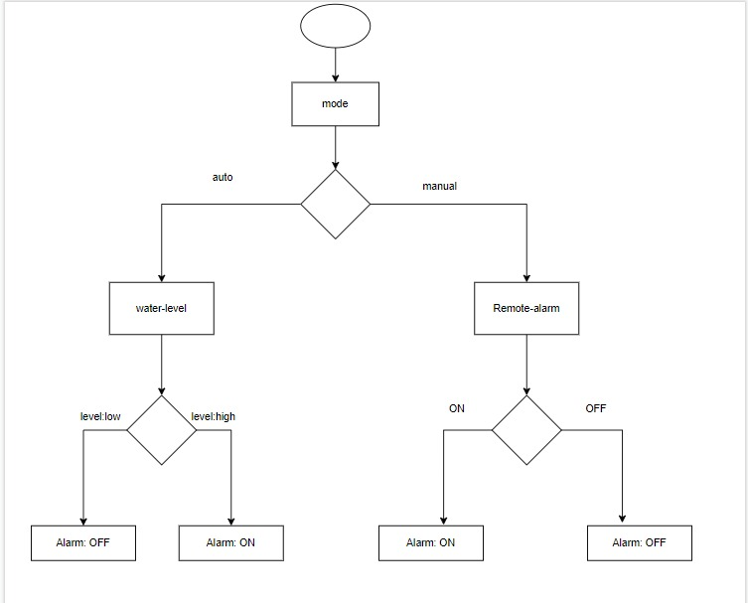

Figure 2 : Process specification for Flood Monitoring & Alerting system

**3.3) STEP 3:** Domain Model Specification

Figure 3 shows the domain model of the flood monitoring and alerting system example. The entities, objects and concepts defined in the model include:

* **Physical Entity**: one of the buzzer which the buzzer conditions are to be monitored and the other buzzer appliance to be controlled.
* **Virtual Entity :** In the flood monitoring and alerting system there is one Virtual Entity for the buzzer to be monitored, another for the appliance to be controlled.
* **Device:** the device is a single-board mini computer which has ultrasonic sensor and actuator (relay switch) attached to it to detect the any risky flood and flood.
* **Resource:** the on device resource is the operating system that runs on single—boardminicomputer

**35**

* **Service :** In the flood monitoring and alerting system there are three(3) services:

1. a service that sets mode to auto or manual, or retrieve the current mode

**(2)** a service that sets the buzzer appliance state to on/off, or retrieves the current buzzer state

**(3)** a controller service that runs as a native service on the device. When in auto mode, the controller service monitor the flood water level and switches the buzzer on/off and updates the status in the status database. When in manual mode, the controller service retrieves the current state from the database and switches the buzzer on/off. The process of deriving the services from the process specification (step2) and information model(step4) is described in the later sections

36

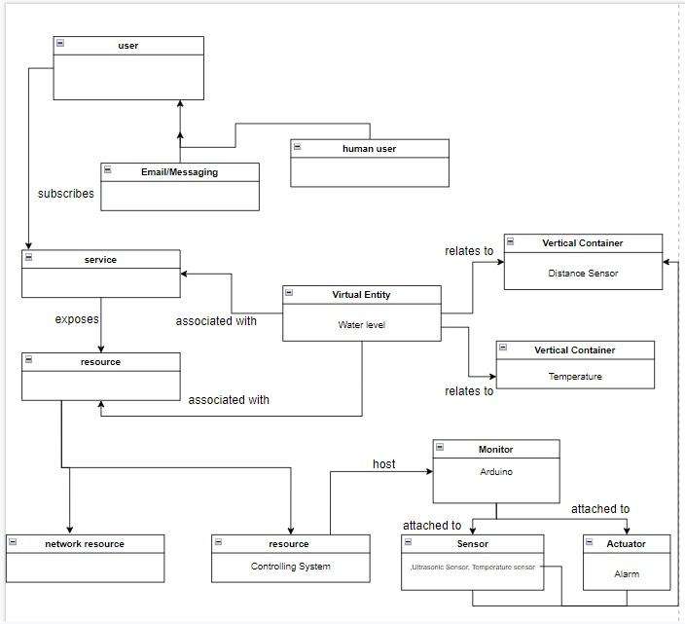

Figure 3 : Domain model of the flood monitoring and alerting of IoT system

**37**

**3.4) STEP 4: Information Model Specification**

ln the flood monitoring and alerting system, there are two Virtual Entities:

* a Virtual Entity for the buzzer appliance (with attribute -buzzer state)
* a Virtual Entity for the surrounding (with attribute – water level )

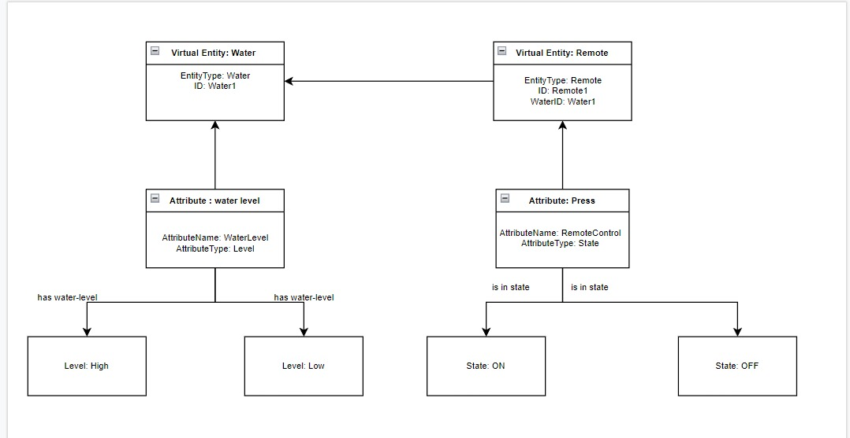

Figure 4: Information model of the flood monitoring IoT system

38

**3.5) STEP 5 : Service Specifications**

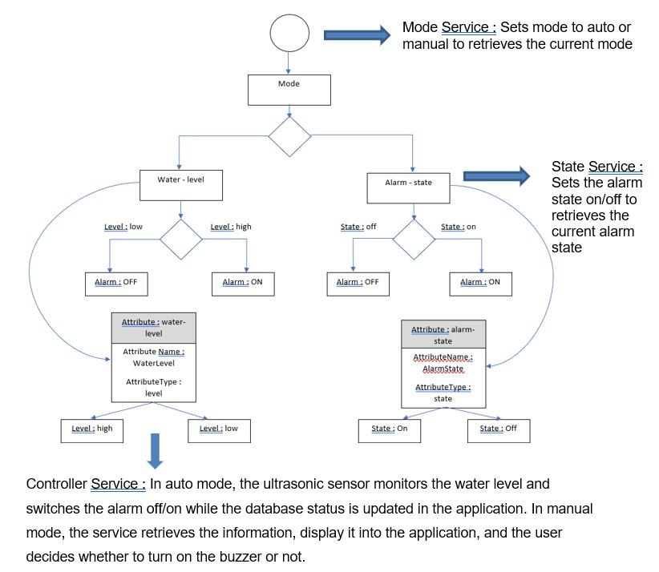

Figure 5: Deriving servicing from process specification and Information model for Flood Monitoring and alerting IoT system.

**39**

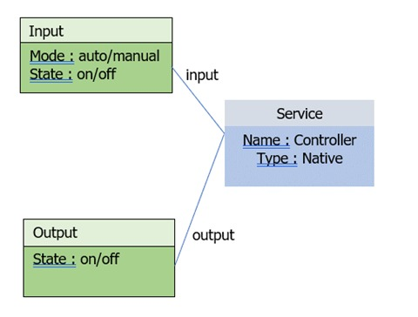

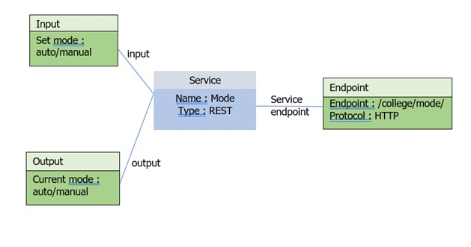

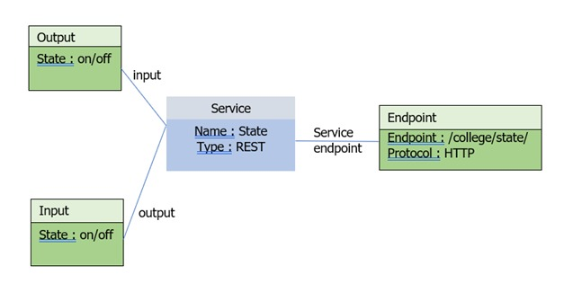

Figure **5.1, 5.2 and 5.3** show specifications of the controller, mode and state services of the flood monitoring and alerting system

**40**

**3.6) Step 6: IoT Level Specification**

The sixth step in the IoT design methodology is to define the IoT level for the system . The deployment level of the flood monitoring and alerting IoT system, which is level-4 .

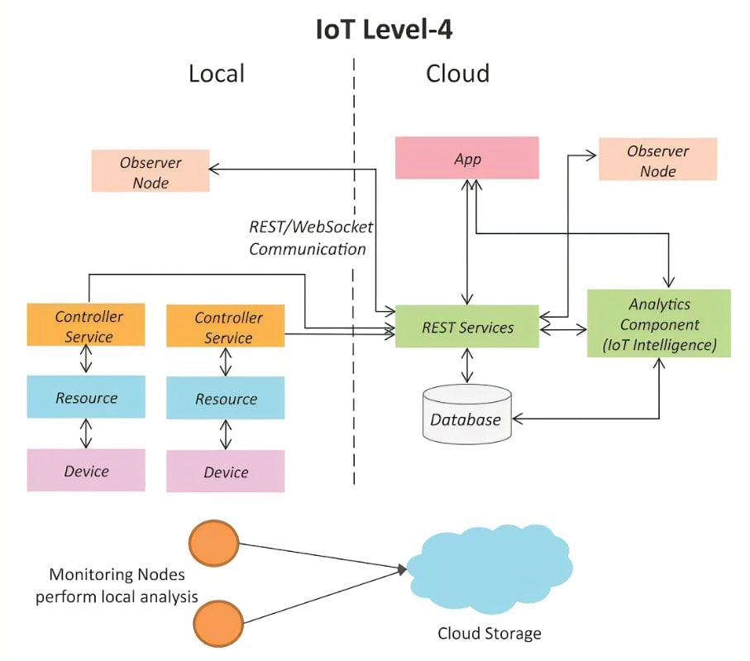

Figure 6: Deployment design of the flood monitoring and alerting IoT system

**41**

**3.7) STEP 7: Functional View Specification**

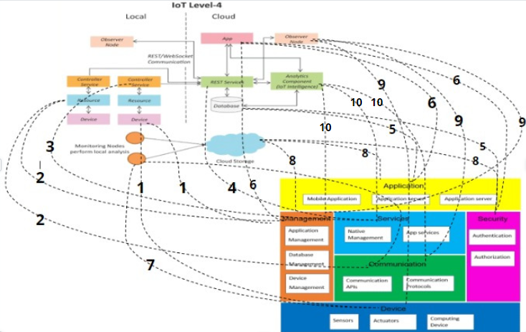

Figure 7: Mapping deployment level to functional groups for flood monitoring and alerting IoT system

p/s : FG stands for Functional Group

* IoT device maps to the Device FG (sensors, actuators devices, computing devices) and the Management FG (device management).
* Resources map to the Device FG (on-device resource) and Communication FG (communication APIs and protocols)
* Controller service maps to the Services FG (native service).
* Web Services map to Services FG.
* Database maps to the Management FG (database management) and Security FG (database security)
* Application maps to the Application FG (web application, application and database servers), Management FG (app management) and Security FG (app security). 42
* Monitoring nodes maps to Communication FG and Device FG
* Cloud storage maps to Management FG , Application FG and Security FG
* Observer maps to Device FG (sensor) , Communication FG (Communication Protovol) and Management FG (Device Management)
* Analytics Components maps to Management FG ( Database Management) , Service FG (Native service) and Communication FG (Communication ApI’s)

**3.8) Step 8: Operational View Specification**

The eighth step in the IoT design methodology is to define the Operational View Specifications. Various options pertaining to the IoT system deployment and operation are defined, such as, service hosting options, storage options, device options, application hosting options, etc.

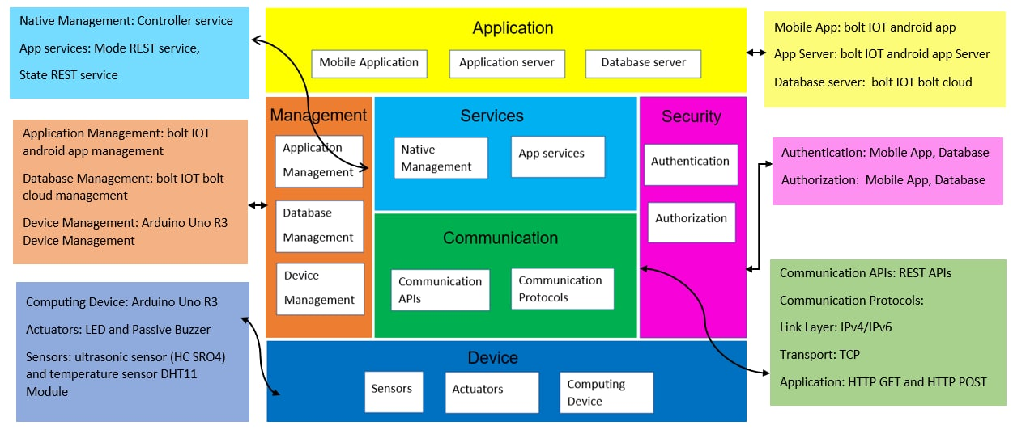

Figure 8: Mapping functional Groups to Operational View for flood monitoring and alerting IoT system

**43**

**3.9) Step 9: Device and Component Integration**

The ninth step in the IoT design methodology is the integration of the devices and components. Figure 9 shows a schematic diagram of the flood monitoring and alerting IoT system.

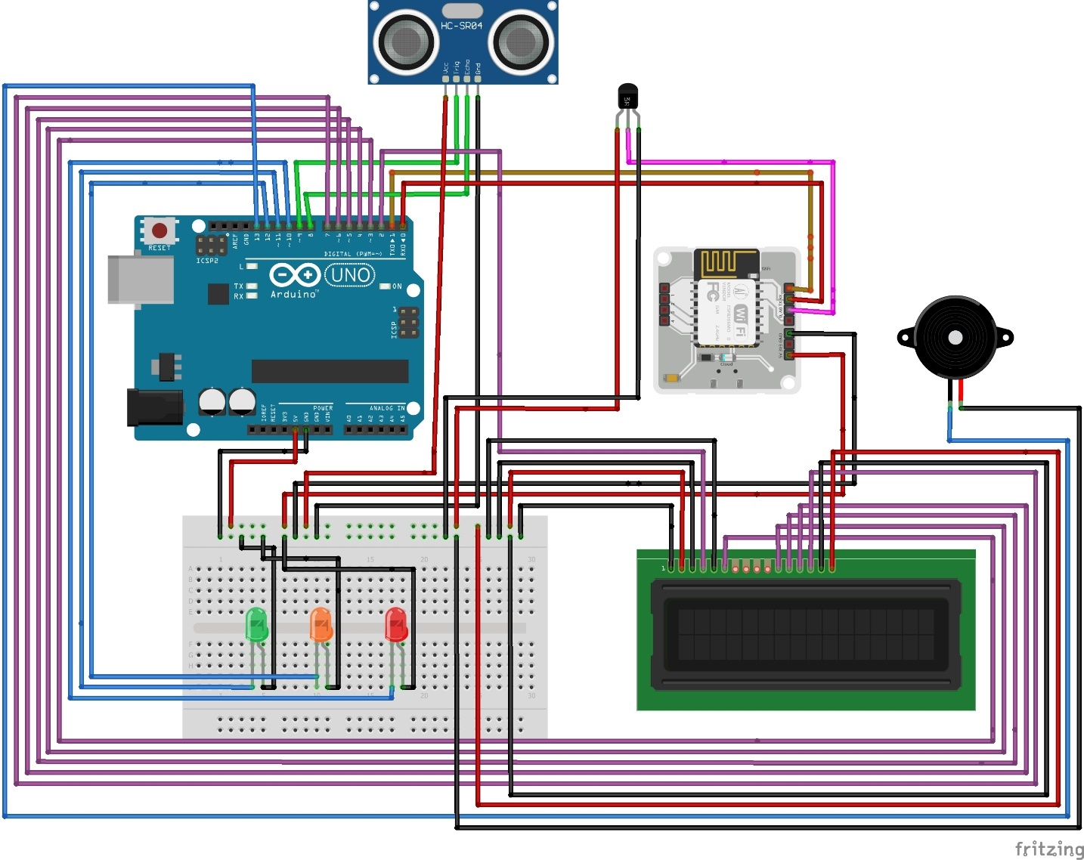

Figure 9: shows a schematic diagram of the flood monitoring and alerting IoT system showing the device, sensor and actuator integrated.

**44**

**Step 10: Application Development**

The final step in the loT design methodology is to develop the IoT application. Figure 10.1 , 10.2 and 10.3 shows a screenshot of the flood monitoring and alerting application android app.

Since it is flood monitoring , so the screen shows the water level and temperature so that people can make preparation facing the risky flood and flood.

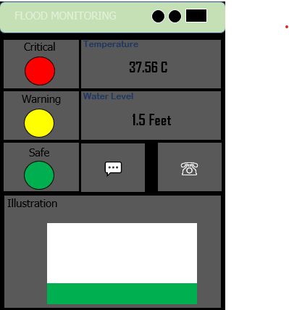

**45**

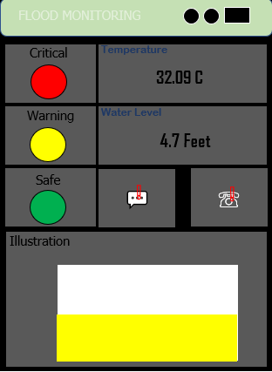

**46**

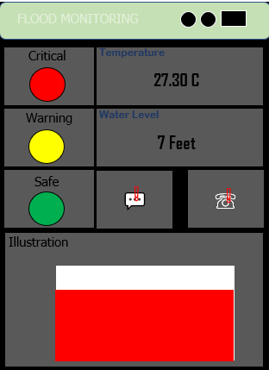

* **SMS & E-mail Alert Button**

Give warning to people to save life by allowing people, support and emergency services time to prepare for flooding.

**47**

1. **Systems-Logical Design using Python for IoT proposed project**

**4.0.1) Setting Up Python for Arduino**

( Upload the StandardFirmata program in Arduino Uno )

**STEP 1 :** Connect Arduino UNO board to PC via USB cable .

The driver might need to be installed for the first usage

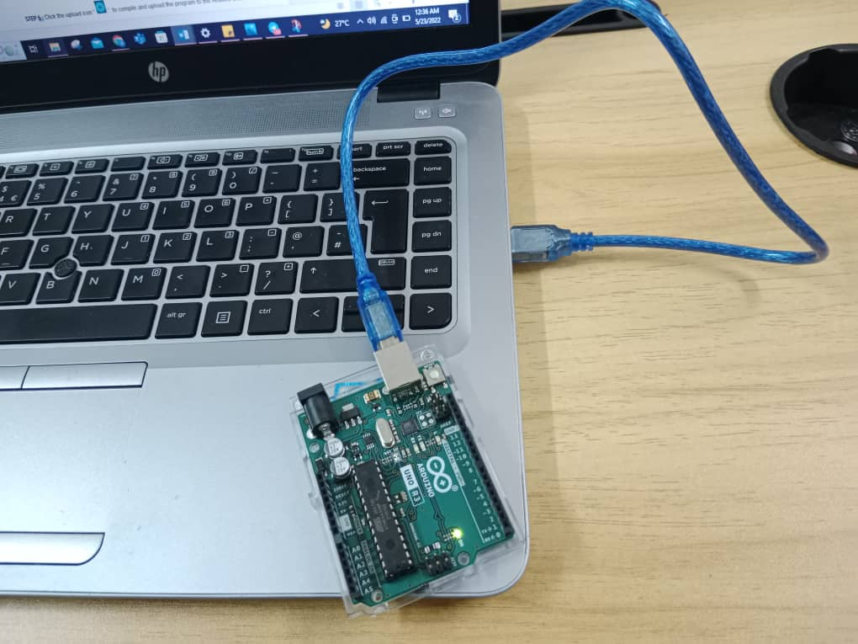

48

**STEP 2 :** Open Arduino Uno

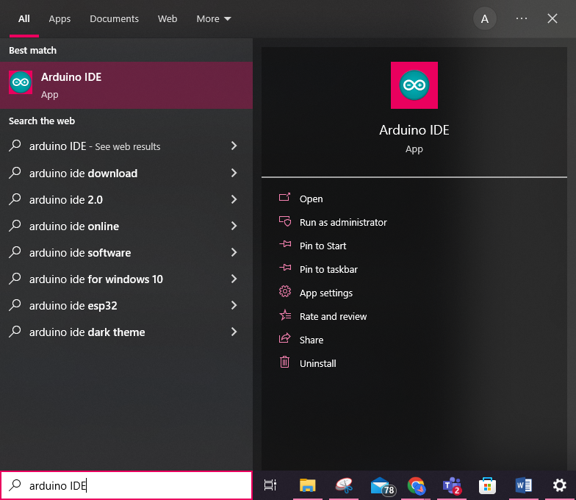

49

**STEP 3 :** Click File > Examples > Firmata > StandardFirmata .

An Arduino IDE window with StandardFirmata code will be opened. Firmata is a generic protocol for communicating with microcontrollers from software on a host computer. It is intended to work with any host computer software package.

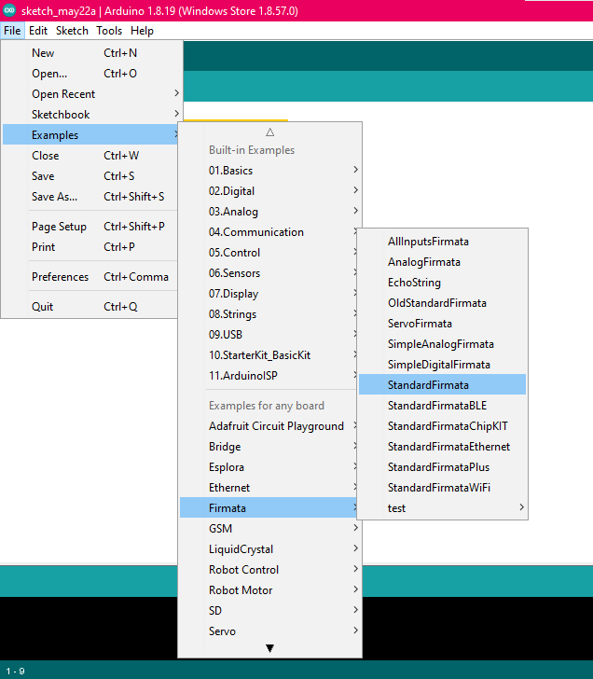

50

**STEP 4:** Click **Tools > Board** to choose the correct Arduino board (e.g. Arduino Uno)

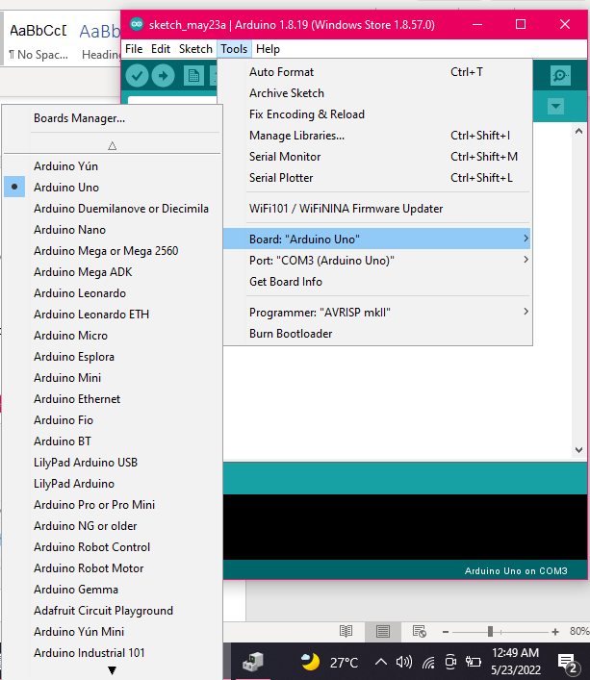

51

**STEP 5 :** Click **Tools > Port** to choose the communication port. If you are not sure which COM port, it can be checked in the Device Manager

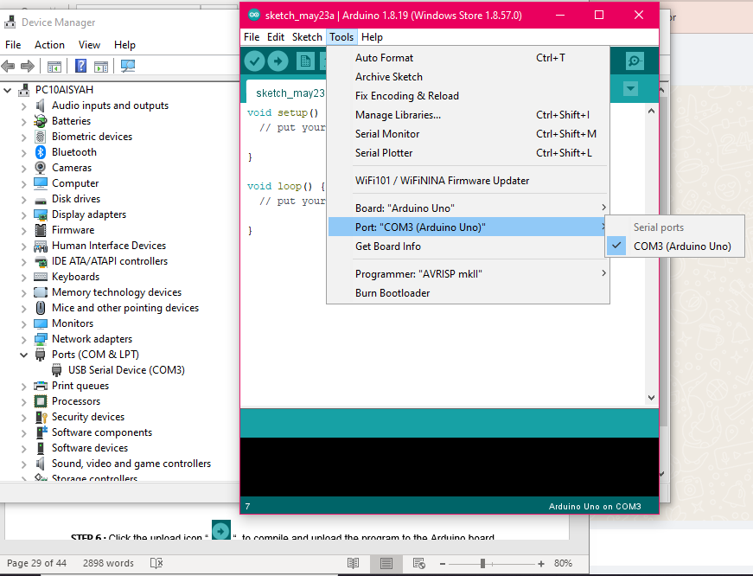

52

**STEP 6 :** Click the upload icon “  “ to compile and upload the program to the Arduino board

Arduino is programmed in a non-volatile memory. So, the program will remain in the microcontroller when the board is reboot (disconnected from the PC). ▪ no need to reupload the program unless there are changes in Hardware setting.

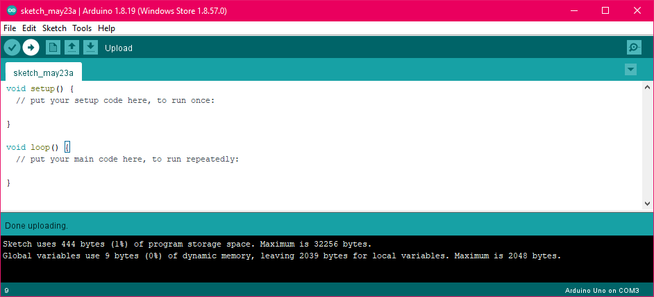

53

**4.0.2) Setting Up Python for Arduino**

**STEP 1:** Download Python IDLE software v3.10.4 .

Select the 32-bit version since it has more complete libraries than 64-bit version

( Link Download : <https://www.python.org/downloads/windows/> )

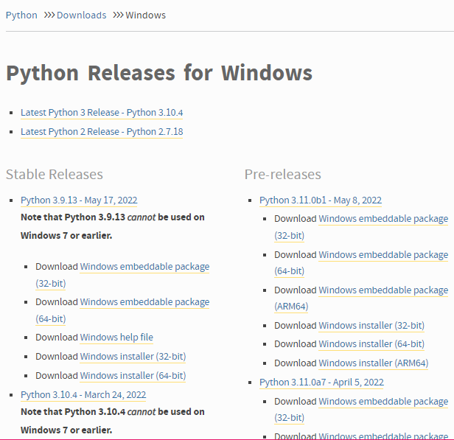

54

**STEP 2:** After finished downloaded , then install the Pyfirmata package at ‘Command Prompt’

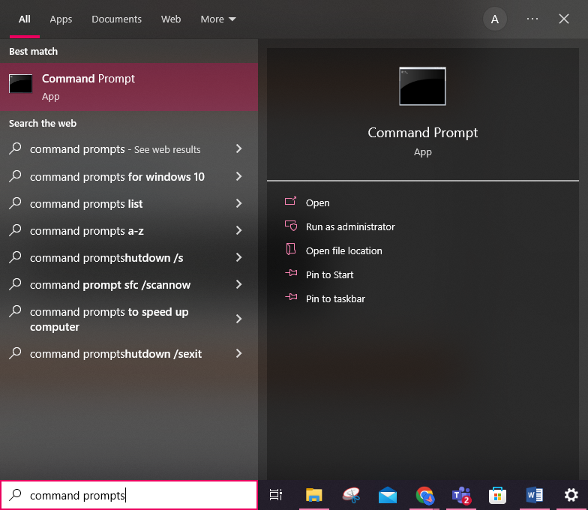

55

Open Windows CMD, type: pip3 install pyfirmata

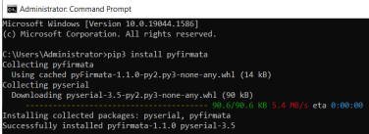

*The picture above shows that the Pyfirmata package was succefully installed

**STEP 3 :** To verify, type in Python IDLE shell: import pyfirmata

If it is correctly installed, no error message will appear.

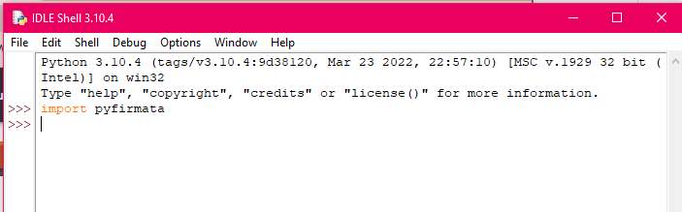

*The picture above shows that the pyfirmata package was executed succefully in Phyton

APPENDIX 1: *The template of Project Proposal.*

1. Introduction (Project overview)
2. Problem Statement
3. Objectives (at least 3 points)
4. Project Methodology
5. Project Costing
6. Gantt Chart/ Timeliness